Manila Water Company
FUNCTIONAL SPECIFICATION – FORM
Receipt Printing for FPE1- Document for Income Tax Withheld and Other Tax With Held
DD_M2C_120

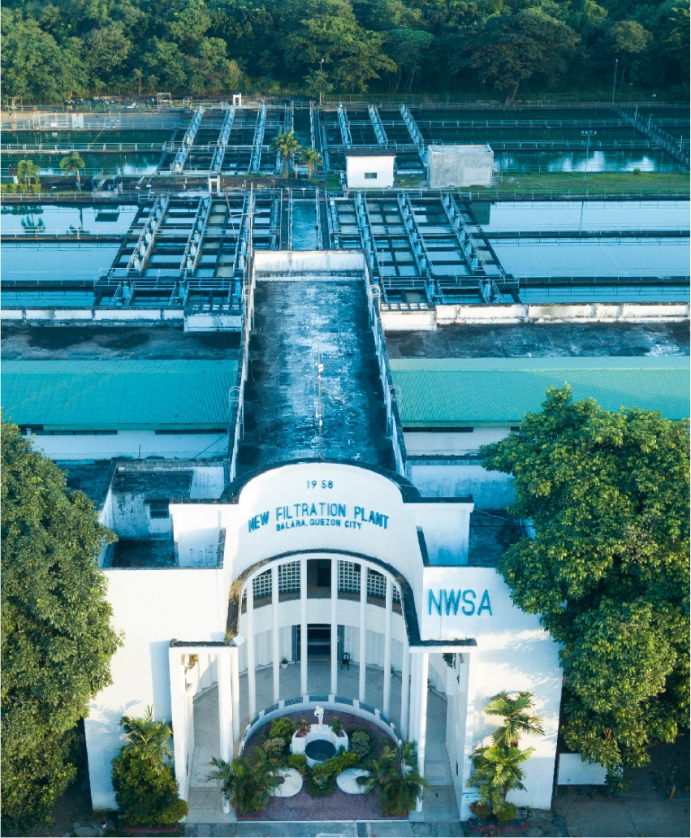

Customer NameDocument Title





Contents
1.1 Document Log 4
1.2 Integration, Document Reference 4
2 Functional Description 4
2.1 Assumptions 5
2.2 Processing Type 5
2.3 Output Type 5
2.4 Functional Design 5
2.5 Security / Authorization Requirements 6
2.6 Process Flow Diagram 6
2.7 SAP Transaction 6
2.8 Form Layout 6
2.9 Printer Requirements 8
2.10 Legal Requirements 8
2.11 Form Fields 8
2.11.1 Main Heading 11
2.11.2 Sub Heading 11
2.11.3 Totaling 11
2.11.4 Sorting 12
2.11.5 Page Breaks 12
2.11.6 Stationery 12
2.11.7 Logo(s) 12
2.12 Bar Coding Requirements 12
2.13 Email Requirements 12
2.14 Existing Sample Forms 12
3 Assumptions in Functional Design 12
4 Open Issues in Functional Design 12
5 Business Test Conditions 13
6 Related Documentation 13
Document Organization
This section provides details about this document, previous version(s) of this document and the document(s) referred.

Document Log
Following table mentions the version changes and the processer(s):
Version | Status | Date | Version Created by (Name/E-Mail/Company) | Role | Comments
1 | Draft | February 17, 2025 | Srinivasarao.koppaku@sap.com | Author | Initial Draft
 | Choose an item. | Click here to enter a date. |  | Choose an item.

Integration, Document Reference

S. No. | Referred Document Name | Referred Document Version | Referred Document URL (Optional)
 | MWC_SDD_FICA_02_Incoming & Outgoing Payment Processing V2.0 | V2.0

The documents listed here are explicitly not part of this Functional Specification. They are not automatically accepted together with this Specification but may be subject to a separate customer/SAP acceptance.

Functional Description
Customers paid their Bills at Cash desk or at payment facility. MWC print the receipt and handover the same to Customers. MWC also can send receipt by e-Mail to customers. e-mail functionality will cover under WRICEF object M2C-DD121.
This FS describes the requirements and details of the receipt printing.
To build the payment receipt based on MWC format, the standard form FI_CA_DOCUMENT_SAMPLE_PDF (Create Z Form copy of Standard form) and application class FI_CA_DOCUMENT can be utilized & designed based on the MWC specific requirement.

Assumptions
Customers paid at cash desk: in this case receipt will be printed immediately and handover the same to customer.
Customers paid at Payment facility: in this customer approach the nearest service area and request for receipt. MWC agent will print the receipt and handover the same.

Processing Type
This form can be printed Real time at cash desk while customer paid their bills.
If the customer paid their bills at Payment facility in that case customer visit the MWC branch/location and requested for Receipt. In that case MWC agent will print the receipt.

Output Type
From can be printed on local printer.
MWC will use A4 paper for printing the form and no pre-printed stationary.

Functional Design

Customers paid their bills at MWC cash Desk or at Payment facility. If customers paid their bills at cash desk and requested for receipt. In this case Cash desk agent print the receipt and handover the same to the customers.
If customers paid their bills at payment facility and customer walk into nearest MWC branch or location and request for receipt. In this case MWC agent will print the receipt and handover the same to the customers.
Standard application form will not fulfill the MWC receipt printing, so we need develop a custom form (Z*) with copy of the standard from FI_CA_DOCUMENT_SAMPLE_PDF.
One common receipt layout will be applicable for both EZ and NEZ customers.

Security / Authorization Requirements
User should have access to print the receipt through FPCJ or FPCOPARA.

Process Flow Diagram
Note Applicable

SAP Transaction
Print the receipt at cash desk through FPCJ.
Print the receipt when the customer approach service area and requested for receipt in this case receipt can be printed through FPCOPARA.

Form Layout

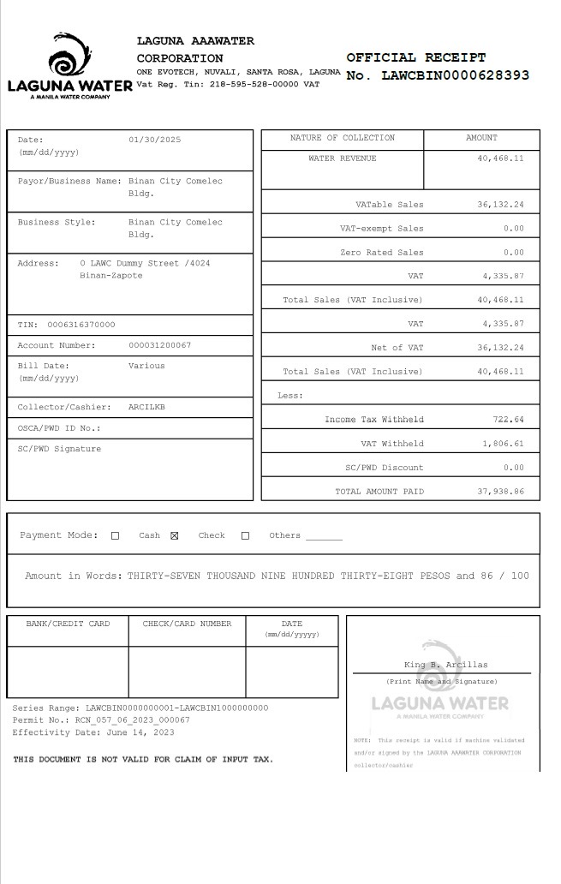

Printer Requirements
Standard printing requirements

Legal Requirements
ODN Number to be printed in the Receipt.

Form Fields

The custom form will be based on the SAP sample FI_CA_DOCUMENT_SAMPLE_PDF.

Derive the given below fields first:

Form Field ID | Field Name | Type | Source Logic
23 | Income Tax Withheld |  | Pick the current document and pass the same in DFKKOP-AUGBL field and validate the DFKKOP-AUGRD field value should be “30” then pick the DFKKOP-SCTAX value  Pass the DFKKOP-SCTAX value in Income Tax Withheld field.
24 | Other Tax Withheld |  | Pick the current document and pass the same in DFKKOP-AUGBL field and validate the DFKKOP-AUGRD field value should be “30” then pick the DFKKOP-SCTAX value  Pass the DFKKOP-STTAX value in Other Tax Withheld field.

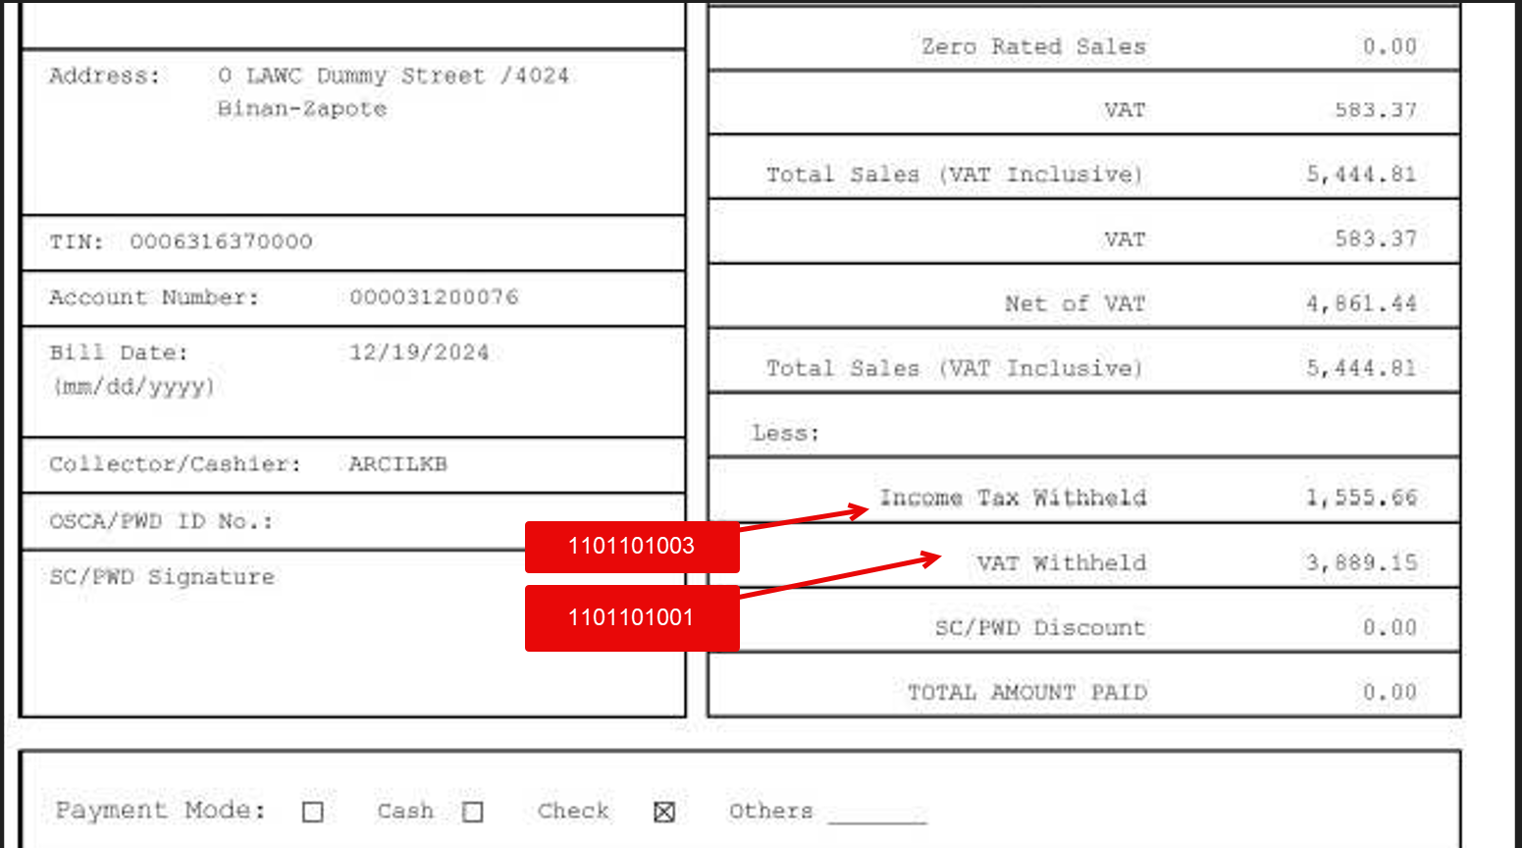
Based on the above details fetch the revenue amount & tax details like given below:
DFKKOP-AUGRD - Clearing Reason (30)

Form Field ID | Field Name | Type | Source Logic
1. | Company Code Name |  | Pass Document number into DFKKKO- OPBEL and take BUKRS and Pass BUKRS into T001- BUKRS and Take BUTXT
2. | Logo | Dynamic | Fixed Logo based on the company code.
3. | Address | Dynamic | Business Palace Address-  Pick the ADRNR field value from table J_1BBRANCH-ADRNR field  Pass the J_1BBRANCH-ADRNR field value in FM ADDR_GET_COMPLETE-ADDRNUMBER field  Get the address details from export parameter ADDR1_COMPLETE under ADDR1_TAB.
 | Vat Reg. Tin: |  | Pass the Company code, Business place and Address field values in  J_1BBRANCH- BUKRS  J_1BBRANCH- BRANCH  J_1BBRANCH- ADRNR (use the same address as above)  And get the J_1BBRANCH-GSTCD value and print the same.
4. | Official Receipt Number | Dynamic | Pass Payment document number into DFKKEXTDOC-EXKEY and take EXBEL value.
5. | Date | Dynamic | Document Date  Posting Date (DFKKZP-BUDAT)
6. | Payor/Business Name | Dynamic | Pass Document number (DFKKOP-OPBEL) generated from cash desk transaction to fetch Business Partner (DFKKOP-GPART).  Pass GPART into BUT000- PARTNER and take NAME_ORG1, NAME_ORG2, NAME_ORG3  Note: Cross check the Invoice printing logic.
7. | Address | Dynamic | Business Partner Address  Following separated by space  House Number BP_ADDRESS-HOUSE_NUM1  Street BP_ADDRESS-STREET  Postal Code BP_ADDRESS-POST_CODE1  City BP_ADDRESS-CITY1  District BP_ADDRESS-CITY2  Region BP_ADDRESS-REGION  Country/Region Key BP_ADDRESS-COUNTRY  Note: Develop common clause to fetch and use the same across all WRICEF Objects.
8. | TIN | Dynamic | Pass BP Number into BUT0ID- PARTNER and TYPE= ZID007 and take IDNUMBER.
9. | Contract account number | Dynamic | Contract account DFKKOP-VKONT
10. | Bill Date | Dynamic | Payment Date (Date on which document posted)
11 | Collector/Cashier | Dynamic | User ID corresponding Name first name and Last name.
12 | OSCA/PWD ID NO: | Dynamic | Blank
13 | SC/PWD Signature | Blank | Blank
14 | Nature of Collection | Fixed | Fixed Text
15 | Amount | Fixed | Fixed Text
16 | Water Revenue | Dynamic | Pass Document number into DFKKOP-AUGBL and get the DFKKOP-OPBEL values,  Come out from the DFKKOP table and enter the DFKKOP-OPBEL values which you identified previously,  Note: Two-line item available with same document number First line is DFKKOP-OPBEL actual revenue item  Second item relevant to WHT where DFKKOP-AUGRD value is “30”  Get the sum of DFKKOP-BETRW value which is total revenue amount.  Note: Follow given below logic as per the 119 FS.  Payment is against only Water Revenue than Heading is Water Revenue. If HVORG(0100,0200 and 0300) then it is Water revenue.  If Payment is against Misc Charges than heading is Misc Revenue. If HVORG(6000) then it is Misc Charges.  If Payment is Mix of Water and Misc Charges than heading is Various Revenue.
17 | VATable Sales |  | Pass Document number into DFKKOP-AUGBL and get the DFKKOP-OPBEL values,  Pass Document number into DFKKOP-OPBEL and KOFIZ (AD ID) = C1, I1, R1, S1 and HVORG(0100,0200 and 0300) and TVORG( 0010,0011,0012,0013,0014,0015,0017,0020,0021,0022, 0023, 0024, 0025, 0027, 0028, 0029, 0030, 0031, 0032, and 0033, then take DFKKOP-BETRW where MWSKZ= O3 (deduct DFKKOP- SCTAX amount from DFKKOP-BETRW and show net amount).  If it is Misc revenue than DFKKOP-OPBEL and KOFIZ (AD ID) = C1, I1, R1, S1,  DFKKOP-HVORG value should be (6000) and DFKKOP- MWSKZ= O3 then pick the DFKKOP-BETRW (deduct DFKKOP- SCTAX amount from DFKKOP-BETRW and show net amount).
18 | VAT-exempt Sales |  | Pass Document number into DFKKOP-AUGBL and get the DFKKOP-OPBEL values,  Pass the payment document number into DFKKOP-OPBEL and identify the DFKKOP-KOFIZ,  If the DFKKOP-KOFIZ value is “C2, I2, R2, S2” and DFKKOP- MWSKZ value is “O2” then pick the DFKKOP- BETRW  Pass the same value in VAT Exempted sales field.
19 | Zero Rated Sales |  | Pass Document number into DFKKOP-AUGBL and get the DFKKOP-OPBEL values,  Pass the payment document number into DFKKOP-OPBEL and identify the DFKKOP-KOFIZ,  If the DFKKOP-KOFIZ value is C3, I3, R3, S3 and DFKKOP- MWSKZ value is “O1” then pick the DFKKOP- BETRW  Pass the DFKKOP- BETRW value in Zero Rated Sales
20 | VAT |  | Pass Document number into DFKKOP-AUGBL and get the DFKKOP-OPBEL values,  Pass Document number into DFKKOP-OPBEL and KOFIZ (AD ID) = C1, I1, R1, S1 and HVORG(0100,0200 and 0300) and TVORG( 0010,0011,0012,0013,0014,0015,0017,0020,0021,0022, 0023, 0024, 0025, 0027, 0028, 0029, 0030, 0031, 0032, and 0033, DFKKOP-MWSKZ = O3,  Then pick the DFKKOP-SCTAX value and pass the same in VAT field.  Note: For company code M001, Tax value should pass the Government Tax field and VATable sales field should be blank.
21 | Government Taxes |  | This field applicable for Company Code M001 only,  Pass Document number into DFKKOP-AUGBL and get the DFKKOP-OPBEL values,  Pass Document number into DFKKOP-OPBEL and KOFIZ (AD ID) = C1, I1, R1, S1 and HVORG(0100,0200 and 0300) and TVORG( 0010,0011,0012,0013,0014,0015,0017,0020,0021,0022, 0023, 0024, 0025, 0027, 0028, 0029, 0030, 0031, 0032, and 0033, DFKKOP-MWSKZ = O3,  Then pick the DFKKOP-SCTAX value and pass the same in Government Taxes field.  For company code M001 – VAT tax is not applicable therefore … blank the VAT tax fields and pick the DFKKOP-SCTAX amount and update the same in this field.
22 | Net of VAT |  | Apply the given below logic if the revenue relevant to Water revenue:  Pass Document number into DFKKOP-AUGBL and get the DFKKOP-OPBEL values,  Pass Document number into DFKKOP-OPBEL and KOFIZ (AD ID) = C1, I1, R1, S1 and HVORG(0100,0200 and 0300) and TVORG( 0010,0011,0012,0013,0014,0015,0017,0020,0021,0022, 0023, 0024, 0025, 0027, 0028, 0029, 0030, 0031, 0032, and 0033, then take DFKKOP-BETRW where MWSKZ= O3 (deduct DFKKOP- SCTAX amount from DFKKOP-BETRW and show net amount).  Apply the given below logic if the revenue relevant to Miss rev:  If it is Misc revenue than DFKKOP-OPBEL and KOFIZ (AD ID) = C1, I1, R1, S1,  DFKKOP-HVORG value should be (6000) and DFKKOP- MWSKZ= O3 then pick the DFKKOP-BETRW (deduct DFKKOP- SCTAX amount from DFKKOP-BETRW and show net amount).  Note: club the water revenue net amount & Misc revenue net amount which is  (deduct DFKKOP- SCTAX amount from DFKKOP-BETRW and show net amount).
22 | Total Sales (VAT Inclusive |  | Pass Document number into DFKKOP-AUGBL and get the DFKKOP-OPBEL values,  Pass the DFKKOP-OPBEL and validate the HVORG value as (0100/ 0200/ 0300/6000) then pick the DFKKOP-BETRW value pass the same in Total Sales (VAT Inclusive) field.
23 | Income Tax Withheld |  | Pick the current document and pass the same in DFKKOP-AUGBL field and validate the DFKKOP-AUGRD field value should be “30” then pick the DFKKOP-SCTAX value  Pass the DFKKOP-SCTAX value in Income Tax Withheld field.
24 | Other Tax Withheld |  | Pick the current document and pass the same in DFKKOP-AUGBL field and validate the DFKKOP-AUGRD field value should be “30” then pick the DFKKOP-SCTAX value  Pass the DFKKOP-STTAX value in Other Tax Withheld field.
25 | SC/PWD Discount |  | Pass Document number into DFKKOP-AUGBL and take HVORG and TVORG  Pass Document number into DFKKOP-OPBEL and take HVORG and TVORG  Amount.  Keep it blank at this point
26 | Total Amount Paid |  | Pass Document number into DFKKOP-OPBEL and pick the DFKKOP-AUGBL value if DFKKOP- AUGRD value is “01”  Pass the DFKKOP-AUGBL value in DFKKZP-OPBEL field and get the DFKKZP-BETRZ value.  If Customer paid Excess amount, in this total paid amount will show in this filed.  If Customer Payment went Clarification than will consider only payment document (document which posted in customer account ) will be considered.
27 | Payment Mode | Dynamic | If Payment is by cash, then Mark as cash Payment  If payment is by check, then mark as Check payment.  If payment is other than Cash and Check then Mark X in others  Payment by Cash: Pass document number into DFKKKO-OPBEL and check HERKF. If HERKF EQ 19 or 20 or 21 then these payments through Cash Desk then pass Payment document number into DFKKZP- OPBEL and take KEYZ1 and Pass KEYZ1 into DFKKCJT- PRKEY and check PAYTP, If PAYTP=CS then it is cash payment if PAYTP=CH than it is check payment.  Payment through Payment facility: In this case check DFKKKO-OPBEL and check HERKF is 05 then this is cash payment. If HERKF is 25 then it is check payment. All other cases mark then as others.
28 | Amount In words | Dynamic
29 | Bank/Card Number |  | Pass DFKKZP-CCNUM
30 | Check/Card Number |  | Pass DFKKZP- CHCKN
31 | Date |  | Date on which receipt printed.
32 | Series Range  Permit No.  Effectivity Date | Fixed Text | Constant as  - CWCCFPZ0000000001-CWCCFPZ1000000000  - C_21C_052023_0000002  - May 17, 2023  THIS DOCUMENT IS NOT VALID FOR CLAIM OF INPUT TAX.
33 | Print Name and Signature & water mark of LOGO | Fixed Text | GLENDA G. CARAYO  ____________________________________  (Print Name and Signature)  NOTE: This receipt is valid if machine validated  and/or signed by the CLARK WATER CORPORATION  collector/cashier

If the receipt printing second time then mark this receipt as reprint in the water mark.

Main Heading

The logo and company name is based on the company code that payment document posted.

Sub Heading
Form contains two Sections. One section is customer related information and other section is Bill and Payment related information.

Totaling

Totaling sections in the form as following
- Total Sales (VAT Inclusive)
- Total Sales (VAT and GST Inclusive)
- Total Amount Paid

Sorting
NA

Page Breaks
NA- It is single page

Stationery
Plain A4 ( no pre-printed stationary )

Logo(s)
To be provided

Bar Coding Requirements
NA

Email Requirements
e-Mail requirement will cover in the other WRICEF ID

Existing Sample Forms
Covered in the above section

Assumptions in Functional Design
NA

Open Issues in Functional Design
NA

Business Test Conditions

Scenario # | Input Selection Criteria | Expected Result
 | MWC user post the WHT amount for the available invoice document through FPE1. | Document should post the document type VW, and GL accounts are 1101101003,  1101101001 Dr. and customer account is Cr.
 | Print the WHT document through FPE3 | Enter the WHT document and select print option or (CTRL+P), spool should generate for the same.
 | Select the relevant spool from the list and print the document | User should get the spool request in SP01. And print it.

Related Documentation

